Assignment Day 5 : Session 1

Q1. Write Java programs to create an array and initialise and print the elements.

Calculate the average of numbers using Array.

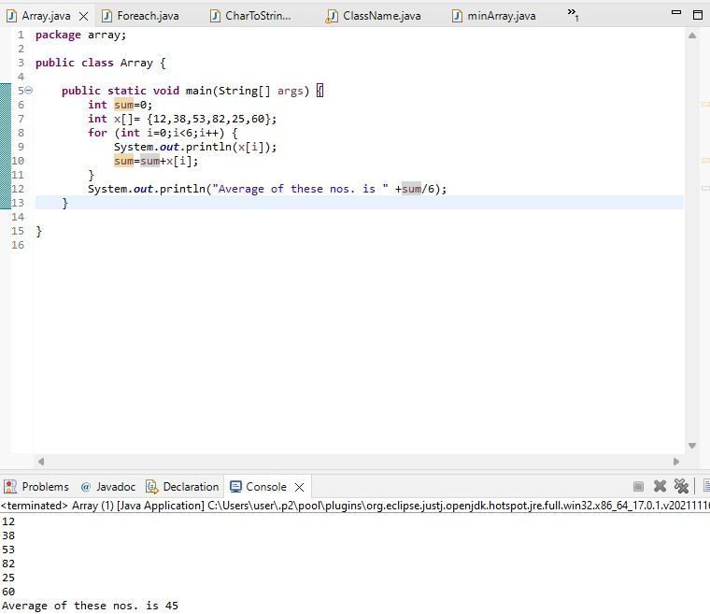

Q2. Print the array elements using for each loop.

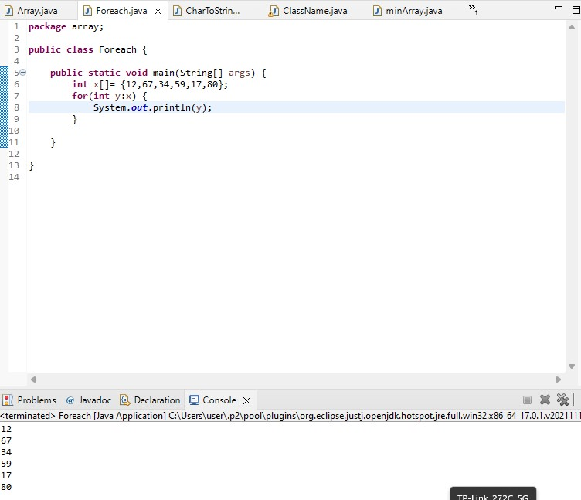

Q3. Convert char Array to String

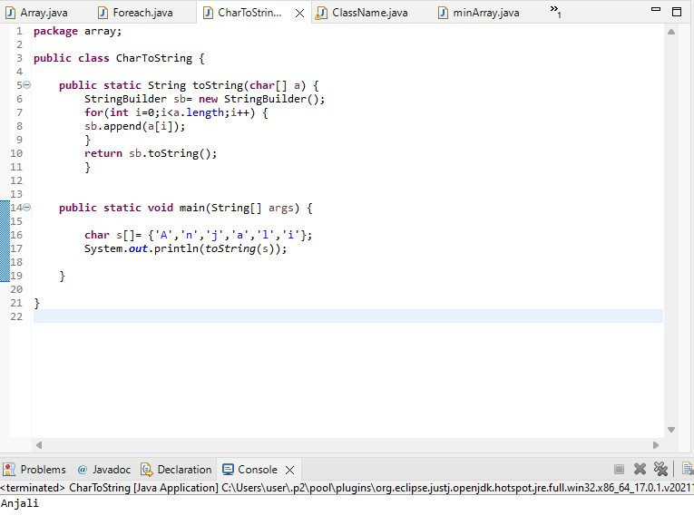

Q4. Add two Matrix using Multi-dimensional Arrays

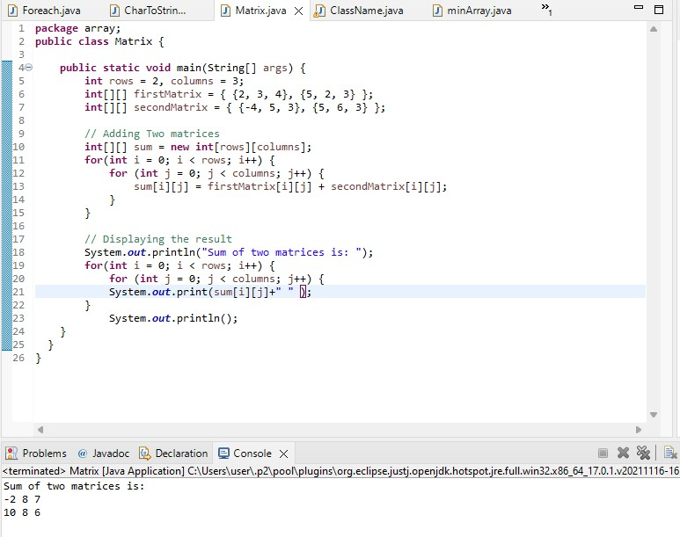

Q6.Write a java program to get the class name of array in java.

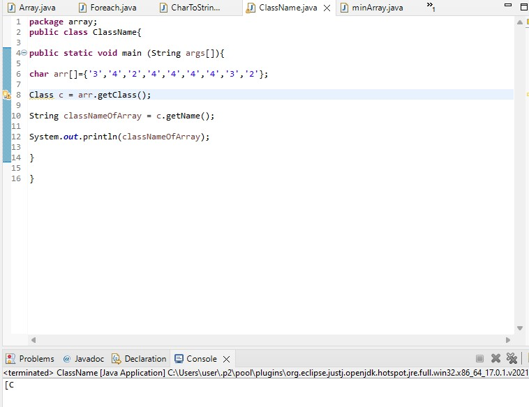

Q7. Find out the min numbers in an array.

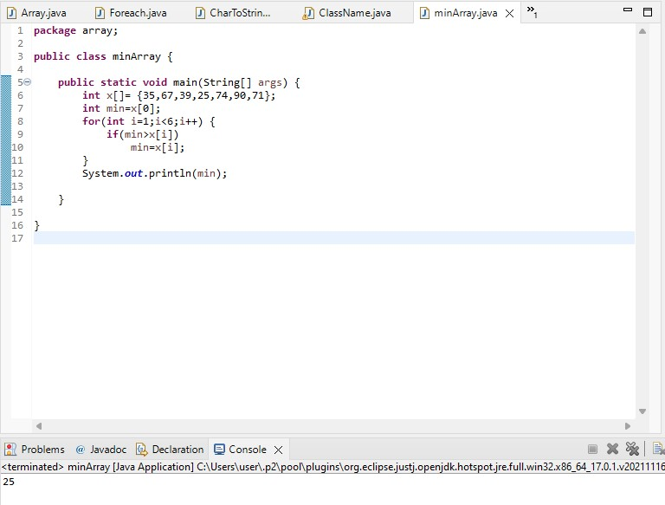

Session 2:

Q1.Create a student class using student properties and create and execute a method without a constructor.

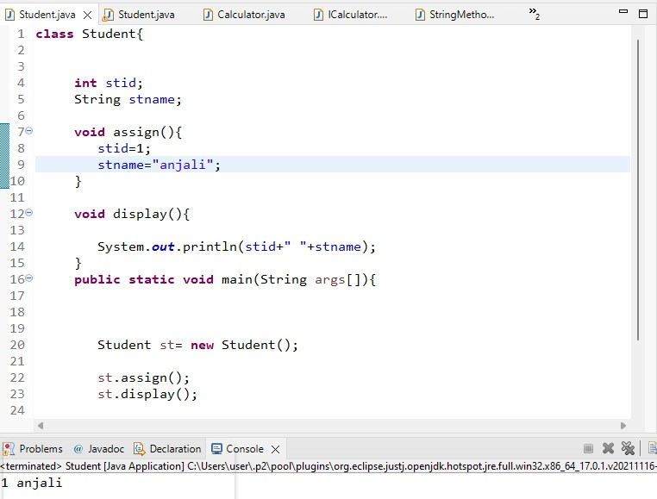

Q2. Create a Product class with constructor (observe the difference with or without constructor)

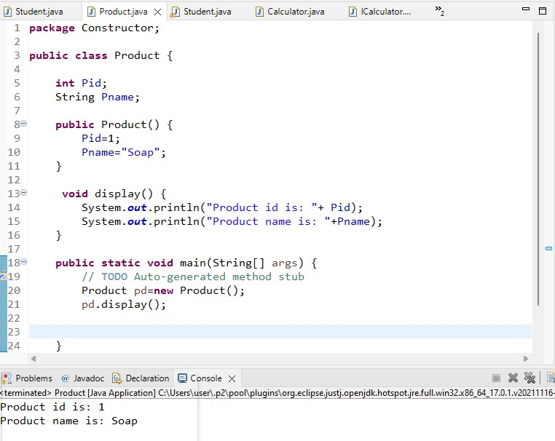

Q3. Create a Student class without parameters and with parameters by using constructor.

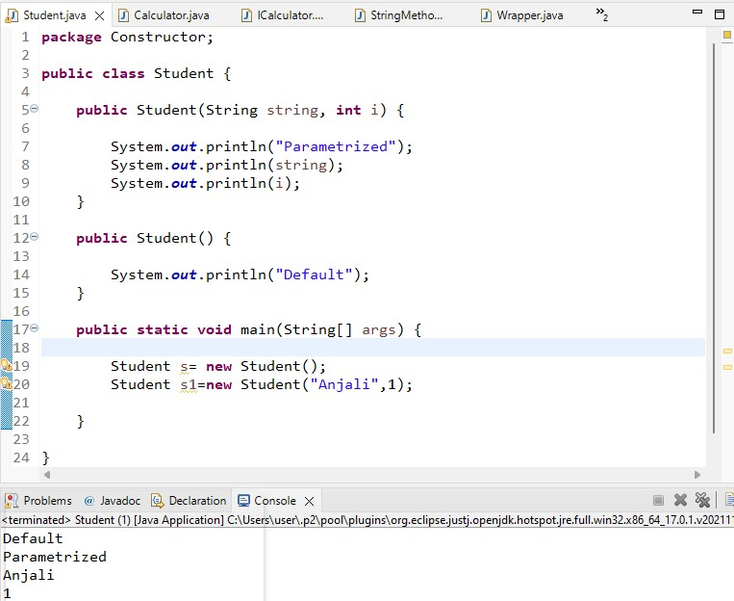

Q4. Create a Calculator class and create static methods with or without return type.

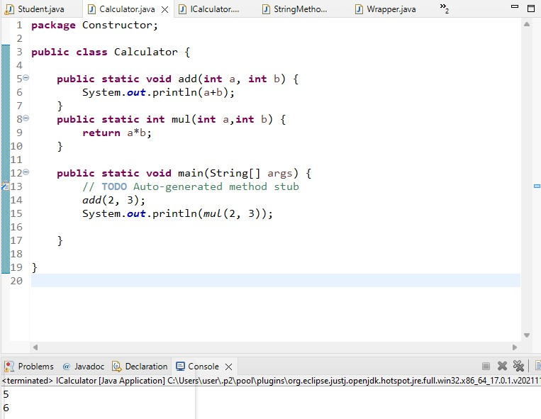

Q5. Create a Calculator class and create instance methods with or without return type.

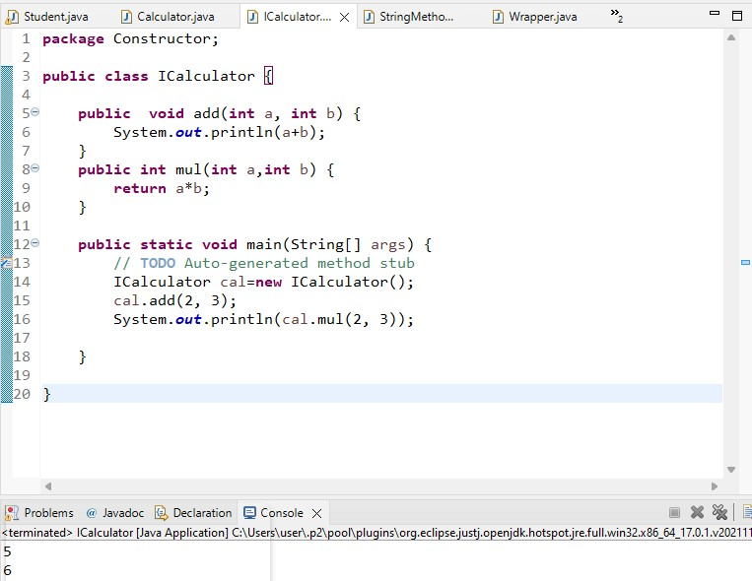

Q6. Create class Test print all the methods of String.

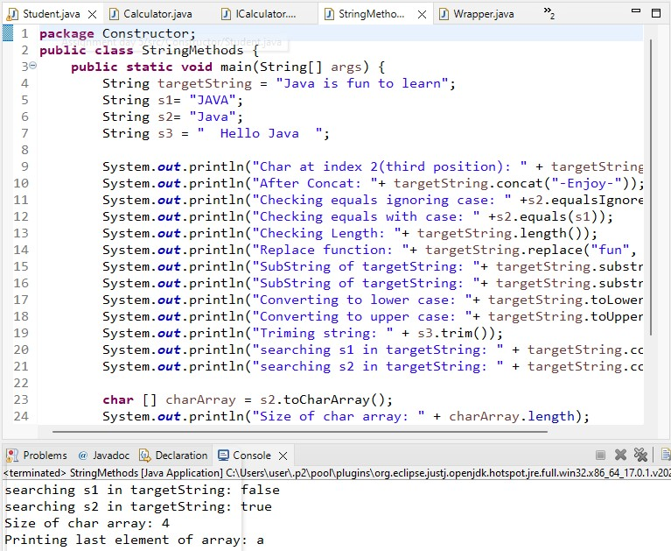

Q7. Create a class Add add two numbers by using Wrapper class.

